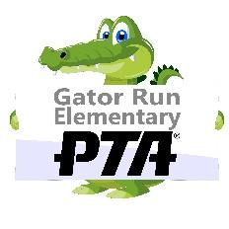
Dear Parents:

I would like to take this opportunity to introduce myself as the Room Parent for
__________________________’s _______ grade class for the 2022-2023 school year.

As Room Parent, I will serve as your primary contact/teacher liaison with respect to classroom events and activities which require classroom volunteers (i.e. holiday party, end of year party, teacher birthday, teacher gifts, school-wide events such as Field Day and Teacher Appreciation, etc.)

A couple of notes from our administration:
- All class communication from the Room Parent must be provided via email. For the safety and privacy of our students, class directories are not permitted.
- We can ONLY collect money on three occasions (winter celebration, end of year celebration, teacher/aid b-day).

Volunteer Information:
- You must have a STAR badge to volunteer at Gator Run. All volunteers must register for the 2022-2023 school year at www.browardschools.com/volunteer. These volunteers will be automatically screened for the new school year and approved volunteers will receive a confirmation email.

- Please visit GatorRunPTA.com it is a great resource to find information and dates for upcoming events, purchase items like your required class shirt, spirit gear, and more.

- Please make sure to record all your off-site volunteer hours (preparing or shopping for a classroom party or school event, work at home for the teacher on a classroom project, etc.). You can now enter your own offsite hours in the Raptor portal. Instructions for doing this can be found at https://gatorrunpta.com/volunteer/

Please feel free to call me with any questions you may have.

Sincerely,
Room Parent: _________________________________________________________
Phone: E-mail:

Co-Room Parent: _____________________________________________________
Phone: E-mail:

