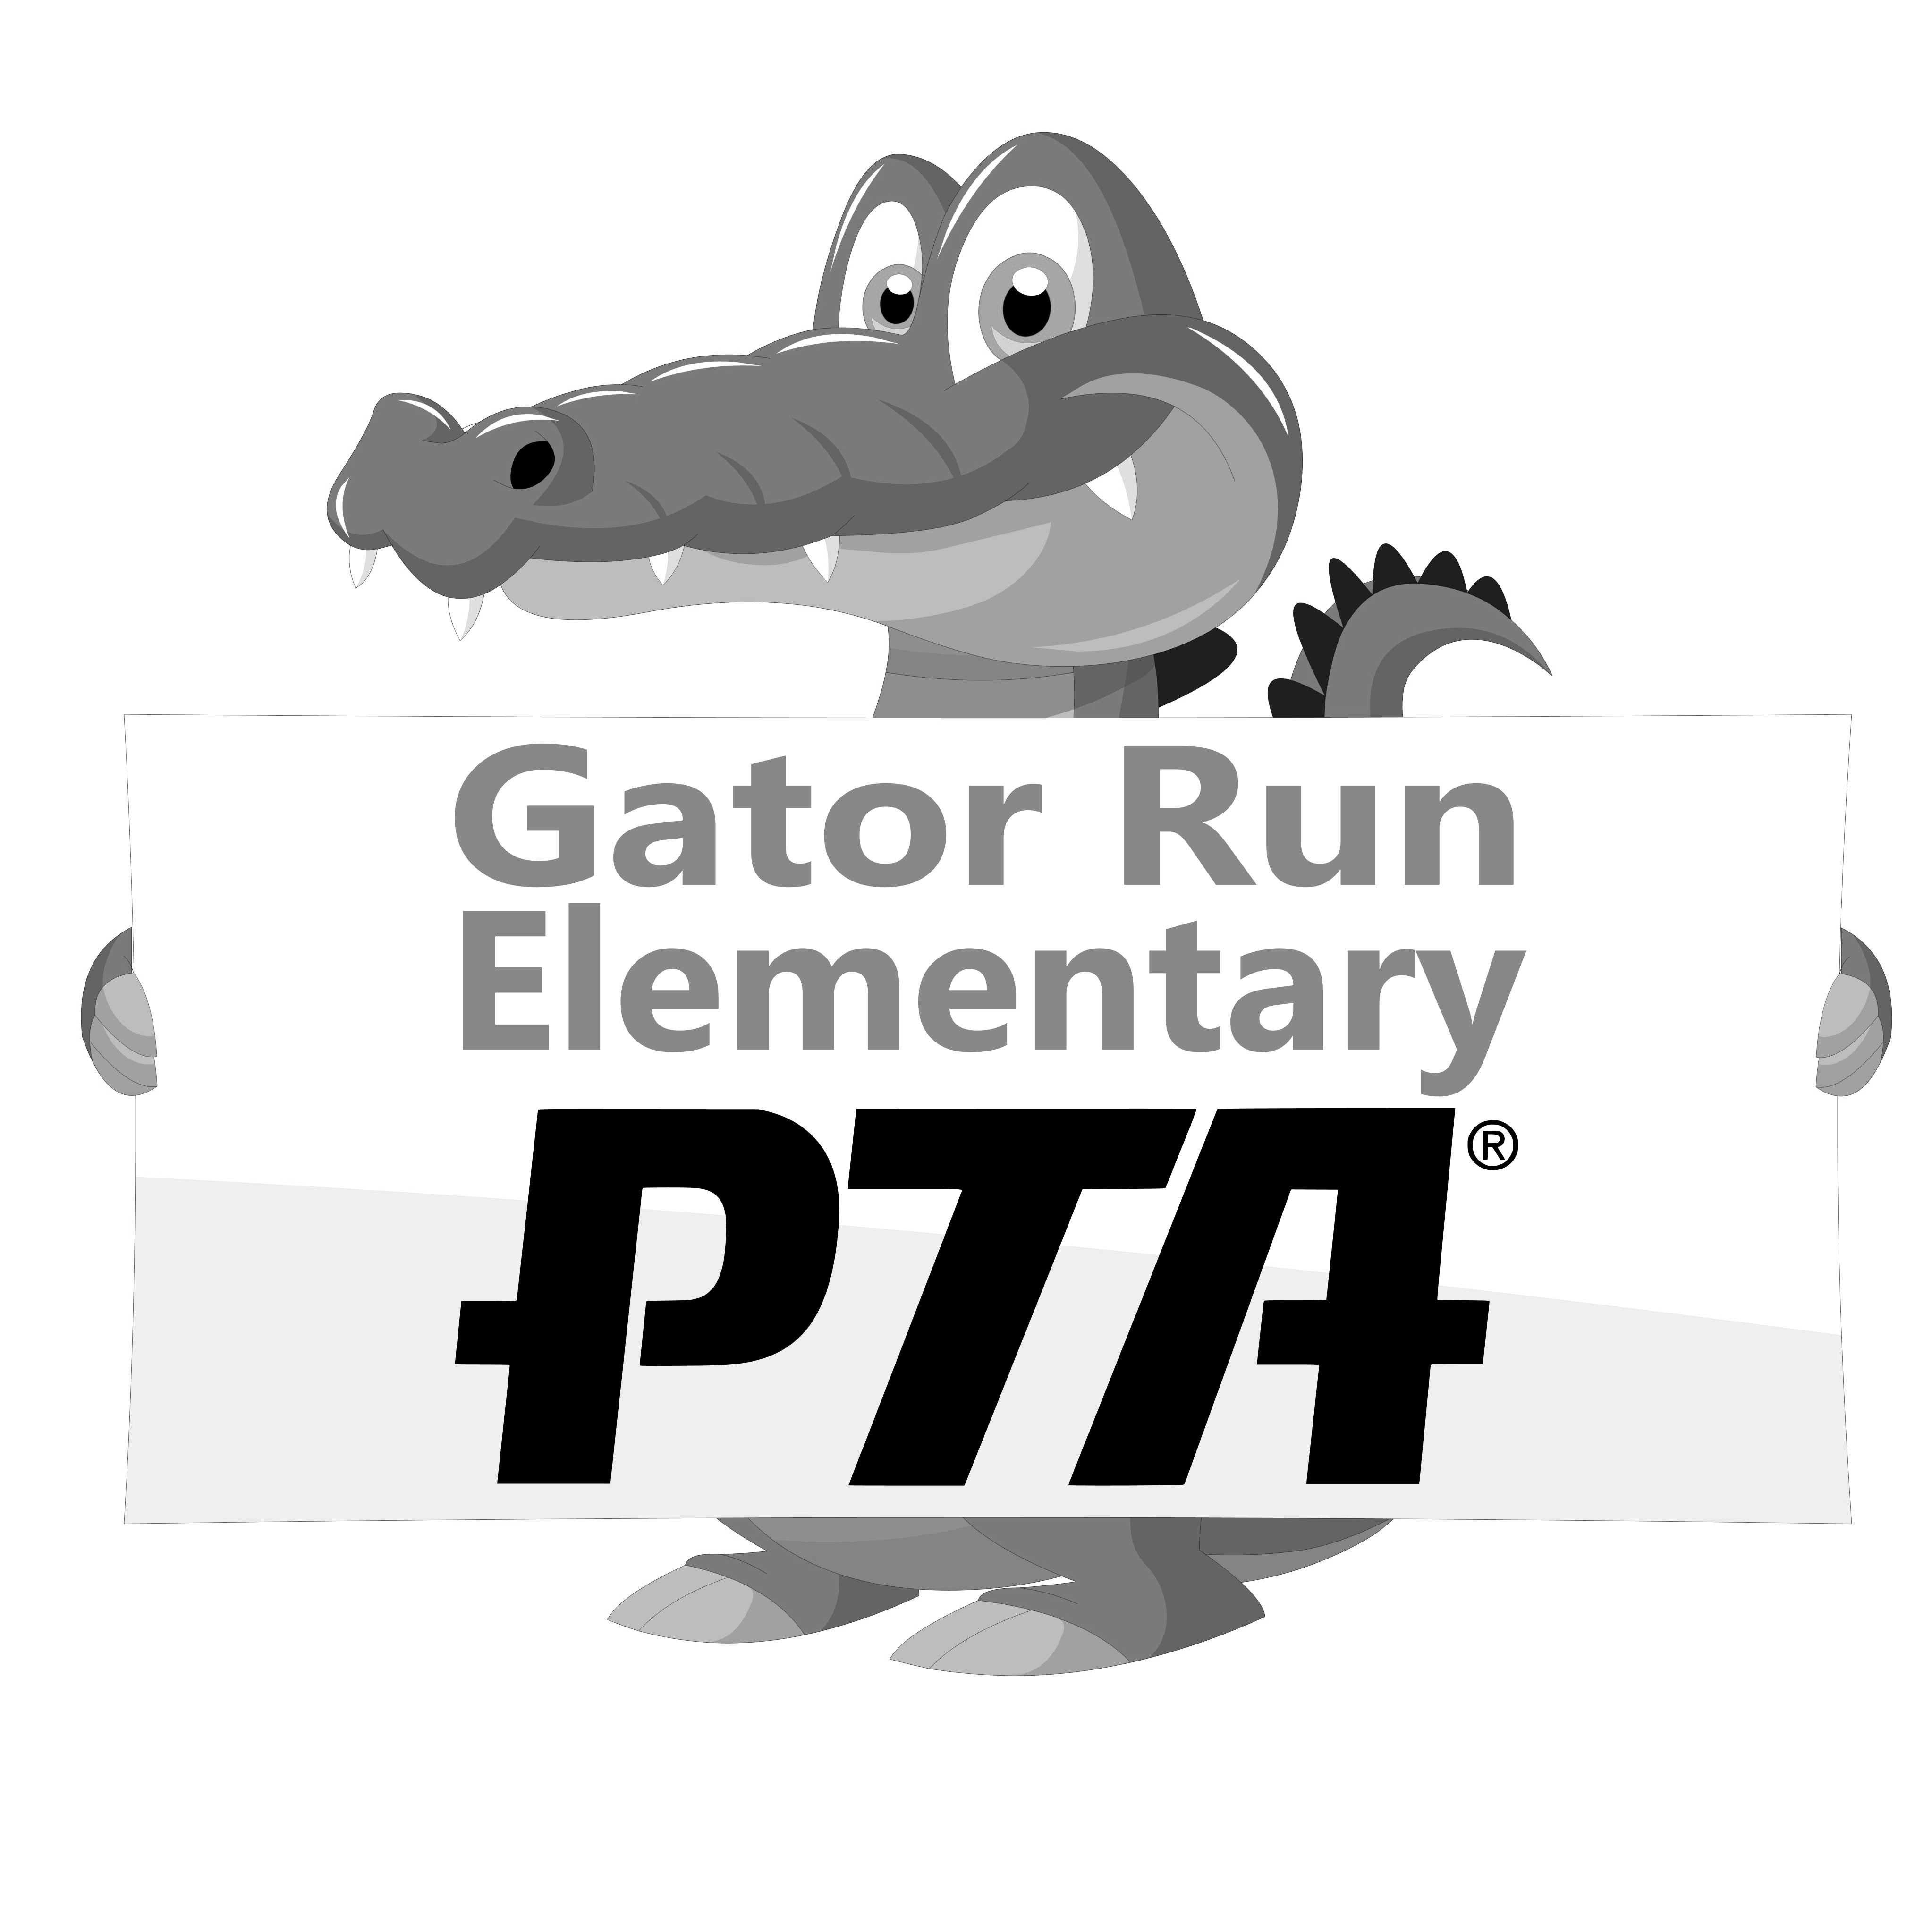
WELCOME BACK GRANTS
Welcome Back Teachers & Paraprofessionals!
The Gator Run PTA would like to help kick off the new school year with a grant to help you with classroom supplies.
- The grant for teachers is $75.00
- The grand for Paraprofessional is $35.00
After you have spent the entire $75.00/$35.00 please submit the original itemized receipt(s) and the completed form below in an envelope marked “Gator Run PTA” and place it in the PTA mailbox.
Thank you for all that you do! We couldn’t have a successful PTA without the Parent-Teacher involvement.
As always, please email the PTA at info@GatorRunPTA.com with any questions/suggestions.

Gator Run Elementary PTA
Request for Check Reimbursement

Date: ______________ Total Amount Requested: ______________
** In order to receive payment, you must attach the original receipts and/or bills.

Make Check Payable to: _____________________________________
Funds used for: ___________________________________ Amount: ___________
Funds used for: ___________________________________ Amount: ___________
Submitted by: ____________________________________ Position: ___________

Approved by: (President or 1st Vice President) _________________________________
_____________________________________________________________________
For Treasurer’s Use Only

Check #:_______ Date Paid: ________ Budget Category: ____________
------------------------------------------------------------------------------------------------------------------------------------

