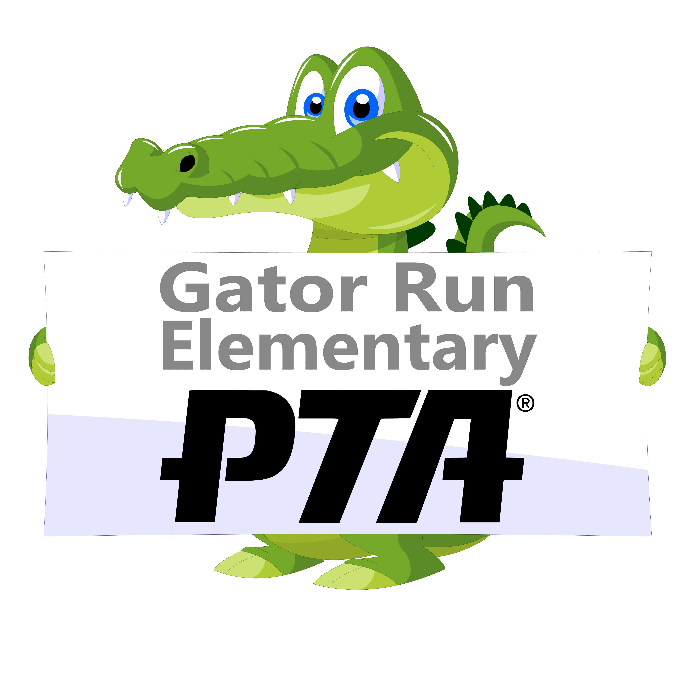

Gator Run Elementary Room Parent Program Guidelines

Welcome to the new school year! Thank you for volunteering to be a room parent! We hope you find this packet helpful.
A Room Parent primary role is to communicates information
between the teacher and the parents of the students.

COMMUNICATION IS THE KEY TO BEING A SUCCESSFUL ROOM PARENT!

Your first assignments as a Room Parent are as follows:

- Meet with your teacher as soon as possible!
- Go to www.gatorrunpta.info – There is a dedicated Room Parent section with all of the pre-approved “Room Parent Introduction letter” Please add your name, phone number and email address and send this home to all the parents to introduce yourself and your Co-Room Parent.
- Mark your calendar with your teacher’s birthday. The collection form for teacher’s birthdays can be found at wwwGatorRunPTA.info
- Find a Class Photographer – either you or a volunteer will be asked to upload 4/5 pictures from each event for the yearbook.

Here are some guidelines about other aspects of your Room Parent Responsibilities

- Volunteering
  - All volunteers must check in at the front office and log in indicating where they will be on campus. Volunteers must wear their Star badge visibly while on school grounds and return it before leaving campus.
  - Please record the time spent volunteering outside of school (e.g. preparing for a party, shopping for supplies, cutting paper etc.). Please record these hours on the “Off Site Hours” form.
Please Note:
All volunteers are required to complete the Broward County Public School Volunteer Application online at www.browardschools.com/getinvolved
Star Badges from last year are no longer valid!!

- Forms & Letters
  - All forms/letters can be found on the Room Parent page on the PTA website at www.GatorRunPTA.info. Please NO changes to forms.

- Contacting Parents
  - Keep in touch with your teacher to find out if any students are added or removed from your class.
  - Teachers must be copied on any email that Room Parents send to parents in the class regarding classroom activities.
  - Parent emails are to be used to distribute Gator Run information ONLY. Please inform us if you become aware that the email system is being used to distribute information not related to Gator Run.

- Parties
  - Two parties are allowed: The Winter Party, which is in December, and the End of Year Party, which is the last week of school in June.
  - Send the pre-approved party letter to the classroom parents a few weeks before the party. No changes can be made to these letters.
  - The Room Parent is responsible for collecting donated money/supplies, coordinating parent volunteers for the parties.
  - Remember that only store bought food is allowed at any school celebration. Homemade food is not allowed. Additionally, the use of any electronic cooking device is not allowed.
  - Pizza or other delivery: If a delivery of any kind has been made for the classroom, it is your responsibility to assure that the Front Office is provided with notice and that payment and tip is provided in an envelope with the name of the company, the teacher’s name & grade and volunteer contact name.

Example:
Jimbo’s Pizza $23.00
Mrs. Class 5th grade
Contact: Volunteer name and phone number
  - Your teacher will let you know how many volunteers are allowed for each party. The number of volunteers for each event is set by Administration – not the PTA. Please do your best to include all parents.
  - Sign up Genius is a great website to ask for volunteers/donations.

- Teacher Gifts
  - In the pre-approved Winter Party and End of Year Party letters, a portion of donated funds are designated for the “teacher gifts”. You must give the teacher the cash you receive or a gift card.
All funds collected for gifts must be used for this purpose, not for party supplies or food.
  - Teacher/Aide birthdays: There is a pre-approved letter for collecting money at GatorRunPTA.info. These, like the other forms, cannot be modified. All teachers/Aides may opt to celebrate their birthday (summer or otherwise) at any point in the school year. Just be sure to celebrate them!

Please remember that:

You are required to schedule any meetings you have with teachers in advance, either by e-mailing them, calling them or by sending in a note with your child. All the teachers very much appreciate your time and effort and they look forward to working with you.

Communication is crucial to the success of the Room Parent. Keep in contact with your teacher and let him/her know you are available. There may be things the teacher will call on you to help with, or he/she may need you to make requests for donations for class projects.

You shouldn’t do or provide everything yourself. It is very important that you give other parents an opportunity to be involved. It is vital that no parent feels left out of an opportunity to benefit the classroom.

The names, telephone numbers and email addresses of your parents are strictly confidential. They are to be used only for the Room Parent Program.
Please remember that when working with students all information pertaining to those students is confidential and not to be discussed outside of the classroom. Also, when volunteering please silence your cell phones and refrain from talking on cell phones and texting while in the classroom.
If you, for any reason, become unable to fulfill your obligations as Room Parent, please let me know as soon as possible. It is encouraged that Room Parents stay informed by going to the PTA General Meetings and by checking our website at www.gatorrunpta.info.
We are here to help and want to do whatever we can to make this a positive experience for you, the children in your classroom and your teacher.

Paula Michaelides
305 926-8601
Michaelides_paula@yahoo.com

THANK YOU and HAVE FUN!

