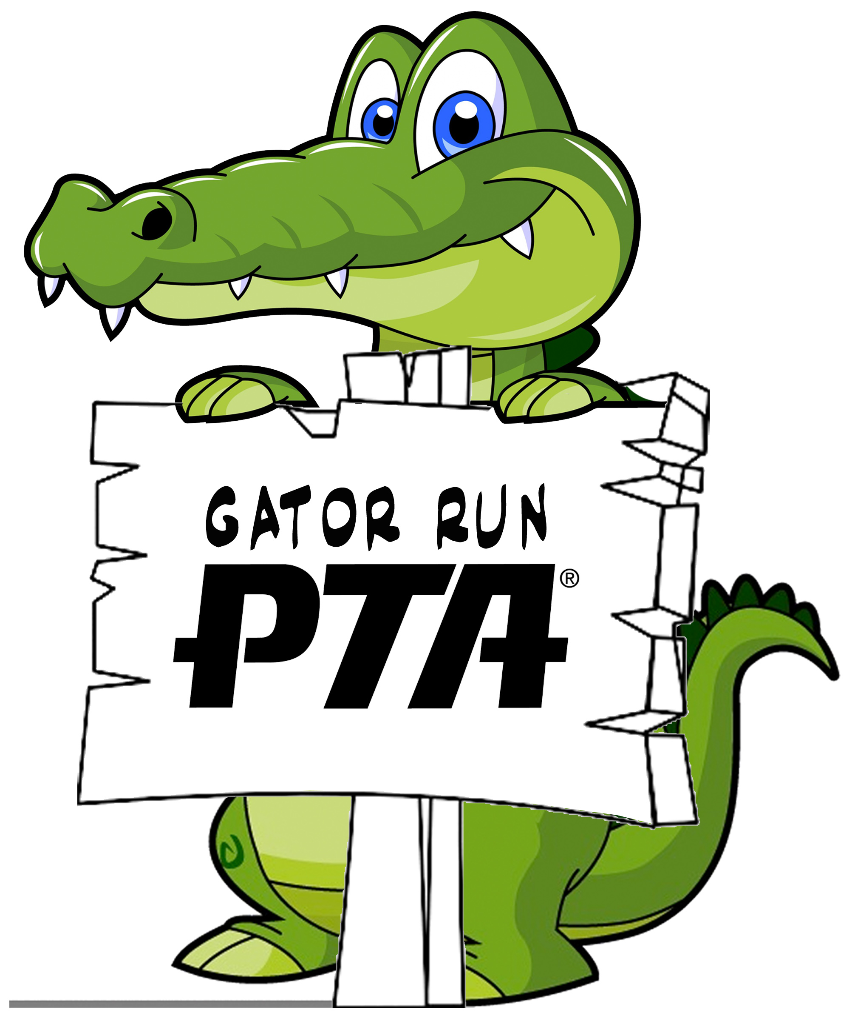 Key PTA Dates 2018 – 2019

DATE EVENT
September 5th-12th Fall Book Fair
September 5th Wednesday - Fall Book Fair Evening Event – 5:30 – 7:30pm
October 3th – 12th Boosterthon
October 12th Friday - Boosterthon Fun Run
October 16th First Multicultural Meeting @9am in cafeteria
October 26th Friday – Fall Family Fun Night
November 28th Evening General Meeting 6:30 PM- 7:30 PM
Jan 14th – Jan 18th Spirit Week
January 23rd PTA General Meeting @9:00 AM in cafeteria
February 22nd Multicultural Festival OUTSIDE
TBD Multicultural Festival Rain-out Date
March 6th – 13th Spring Book Fair
March 8th Friday - Spring Book Fair Evening Event 5:30pm – 7:30pm
May 6th – May 10th Staff Appreciation Week
May 22rd PTA General Meeting and Elections @ 9am in cafeteria
May 29th – June 4th 5th Grade Activities Week

