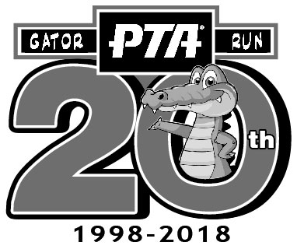
Gator Run PTA
Sponsor Banner Guidelines
2018 - 2019

Sponsors are invited to produce a banner that the PTA will hang on the car pool fence. Business sponsors are responsible for creating and purchasing the banner.

- Size of banner: Banners can be 3’ x 5’ or 4’ x 6 in dimension. Please include grommets when producing your banner. Banners with grommets last longer and look better when they are hung. The more grommets your banner has along the perimeter, the better you banner will look when it is hung. It will also last longer.

- Approval of banner: All banners must be approved by Gator Run administration before being displayed. Please email the image of the banner (artwork and text) exactly as it would appear on the banner to alexandra.mcclay15@gmail.com. Once the banner is approved, we will notify you.

- Weather emergency: If there is a weather emergency (hurricane, wind storm, etc.), Gator Run PTA will do our best to remove the banner before the event. Any damage sustained by weather is the responsibility of the business sponsor.

- Repair: If the banner rips or sustains damage, it is the responsibility of the business sponsor, not of Gator Run PTA, to replace or repair the banner.

- Removal: Gator Run PTA; if the banner becomes in need of repair or replacement; or if required for any safety reasons.

- Hanging of Banners: Banners will be hung upon delivery to school. They will remain up for the duration of the current school year.

