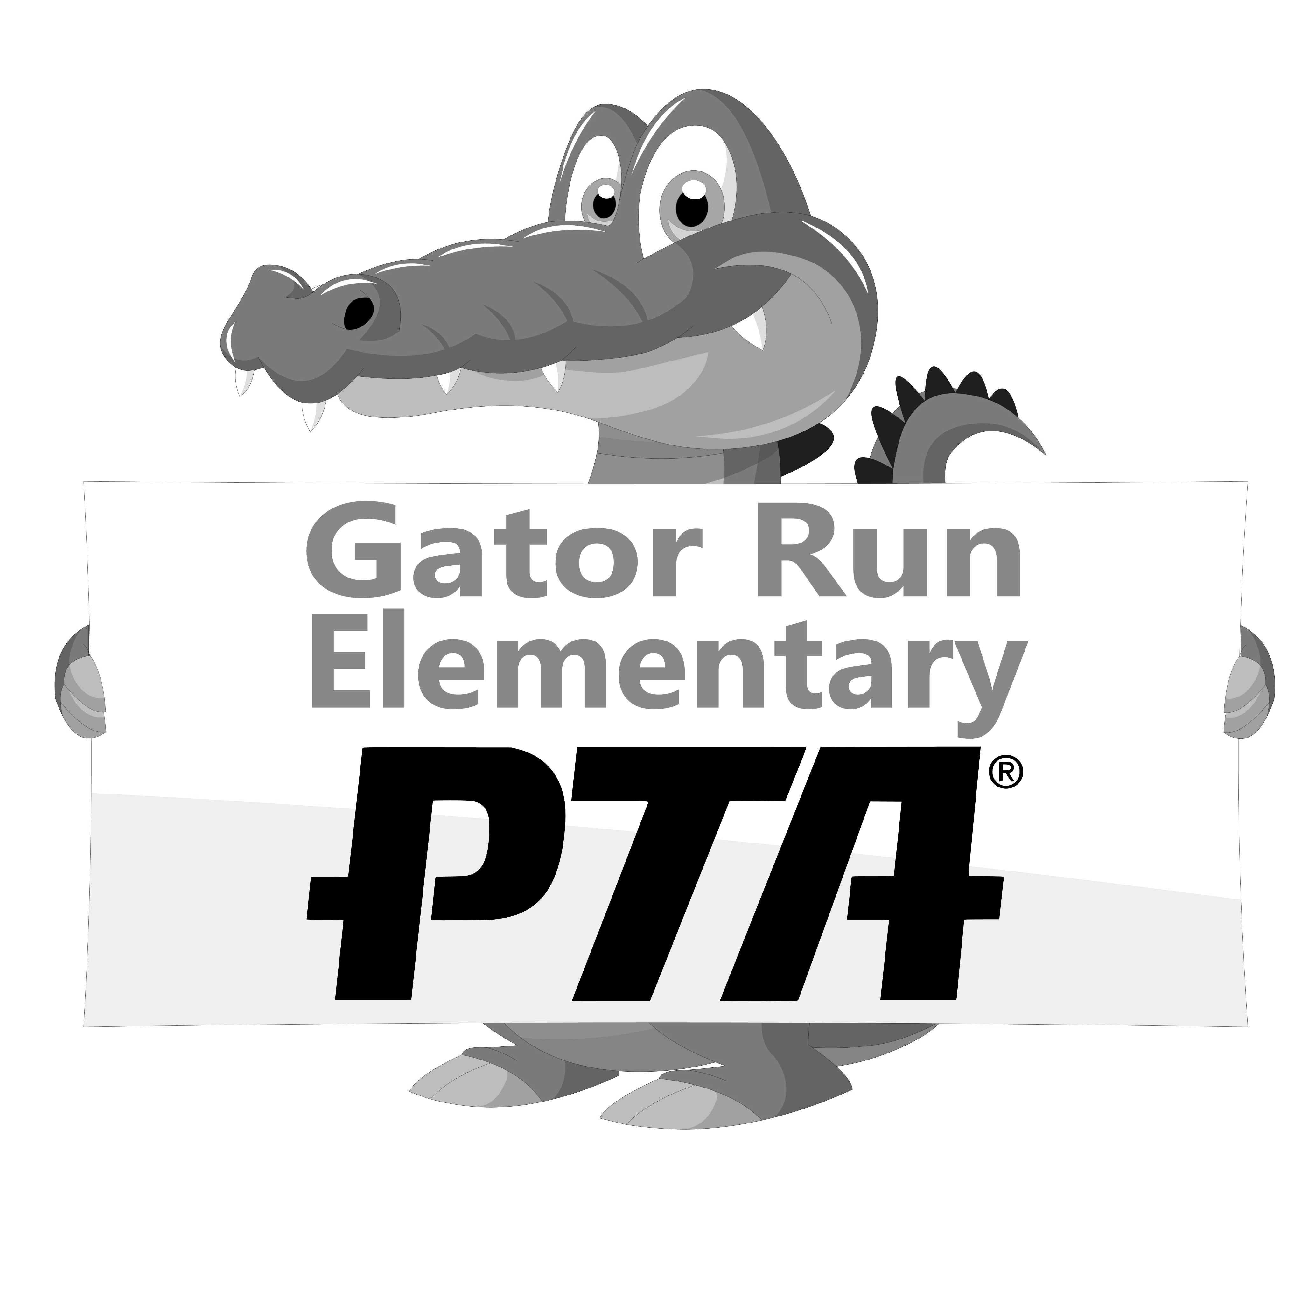
Happy New Year GRANTS (2021)
Happy New Year to our Teachers & Paraprofessionals!
The Gator Run PTA would like to help ring in the new with a grant to help you with classroom supplies.
- The grant for teachers is $75.00
- The grand for Paraprofessional is $35.00
After you have spent the entire $75.00/$35.00 please submit a photo of the original itemized receipt(s) and a photo of the completed form below by emailing them to greptatreasurer@gmail.com
Thank you for all that you do! We couldn’t have a successful PTA without the Parent-Teacher involvement.
As always, please email the PTA at info@GatorRunPTA.com with any questions/suggestions.

Gator Run Elementary PTA
Request for Check Reimbursement

Date: ______________ Total Amount Requested: ______________
** In order to receive payment, you must attach the original receipts and/or bills.

Make Check Payable to: _____________________________________
Funds used for: ___________________________________ Amount: ___________
Funds used for: ___________________________________ Amount: ___________
Submitted by: ____________________________________ Position: ___________

Approved by: (President or 1st Vice President) _________________________________
_____________________________________________________________________
For Treasurer’s Use Only

Check #:_______ Date Paid: ________ Budget Category: ____________
------------------------------------------------------------------------------------------------------------------------------------

